Requirement list of Find User ID menu in mobile app

내용

1. Requirement history 2

2. Requirements Purpose 3

3. Requirements List 3

# Requirement history

|  |  |  |  |  |
| --- | --- | --- | --- | --- |
| Version | Date | Author | Type | Contents |
| V1.0 | 2021-12-23 | Sapumal | Find ID/ Password | Option to find the user ID from mobile app before login |
|  |  |  |  |  |

# Requirements Purpose

The Main purpose of this logic is to enable customers to find their user IDs from mobile app without contacting GME staffs

# Requirements List

* + - 1. Rename “Forgot Password” menu to “Forgot User ID or Password?”
      2. Add “Find User ID” option in password reset window above the password reset field
      3. Add field to enter “registered mobile number” and “Find User ID” button under find user ID option
      4. When the customer enters mobile number and if the mobile number belongs to KYC completed customer, open window to enter DOB. And if the DOB and mobile number match with data in system, send user id as SMS and Email
      5. When the customer enters mobile number and if the mobile number belongs to non-KYC customer, open window to Select Native country. And if the Native country and mobile number match with data in system, send user id as SMS and Email

**Mobile Application**

**Find user ID of approved customer:**

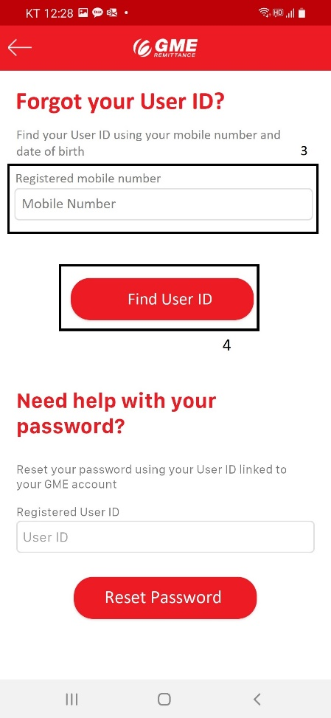

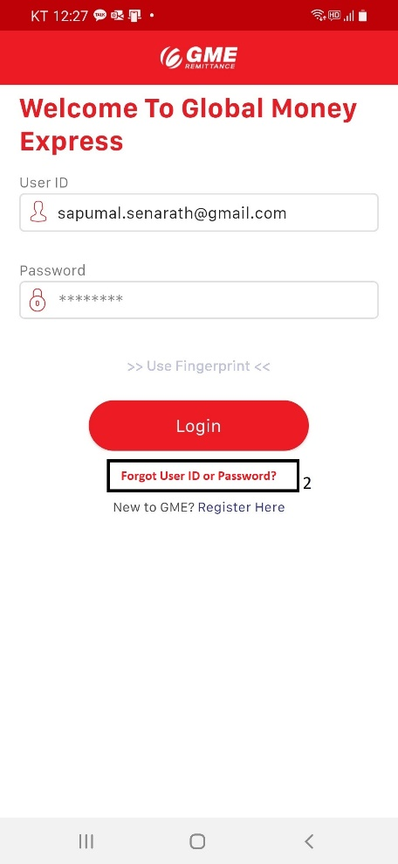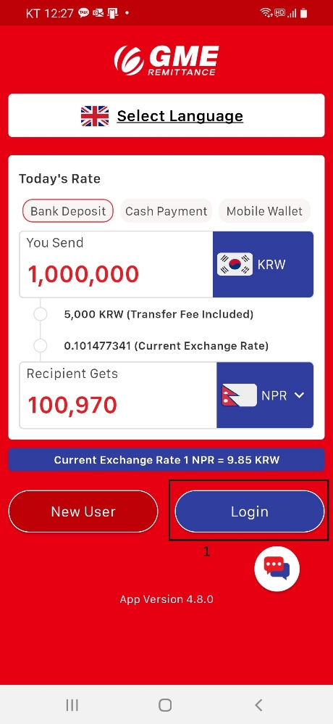

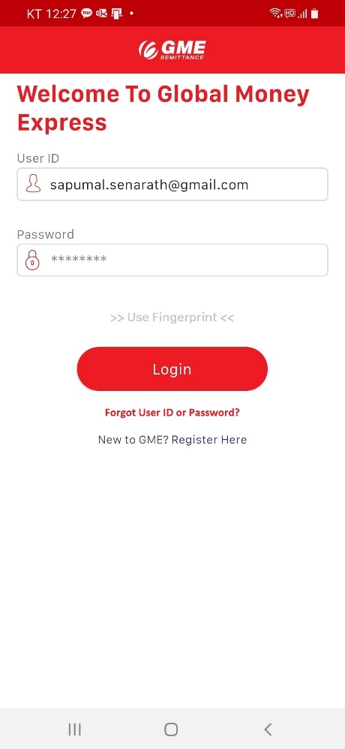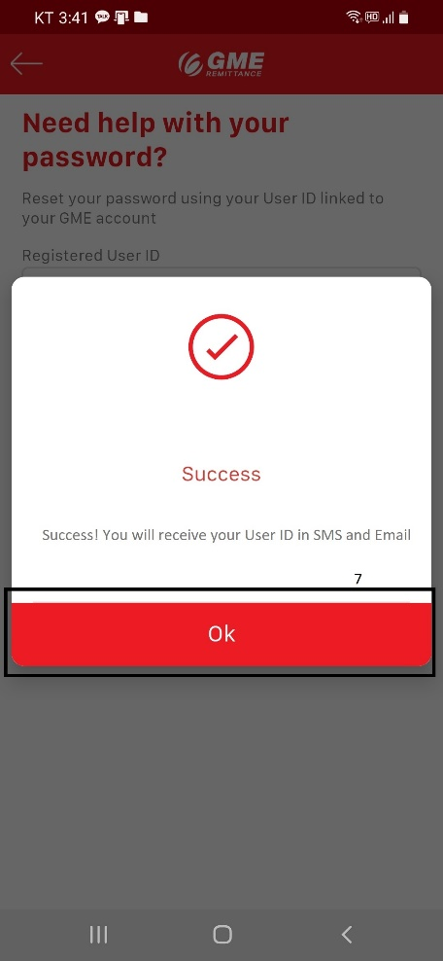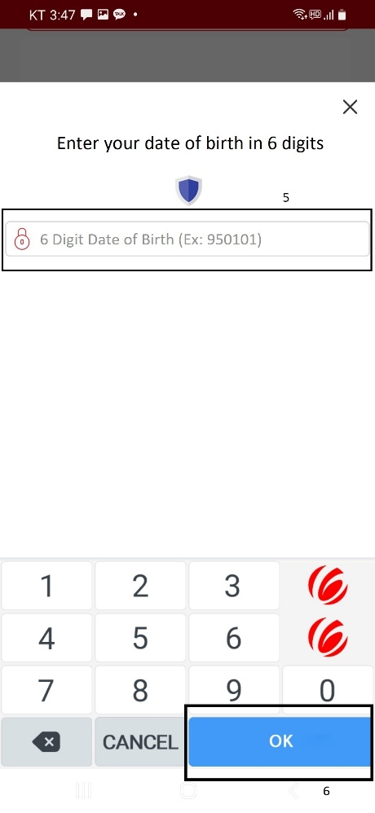

**Find user ID of Non-Kyc customer:**

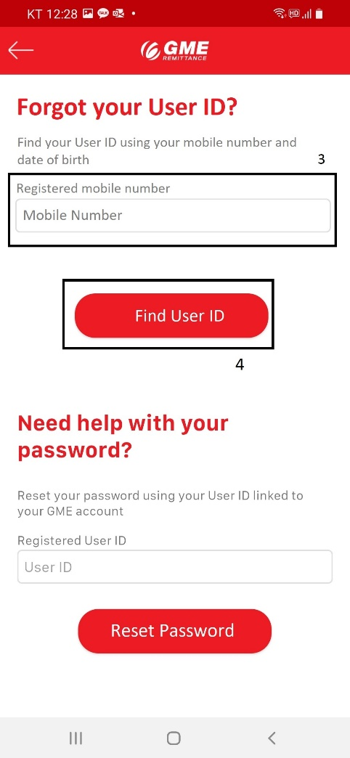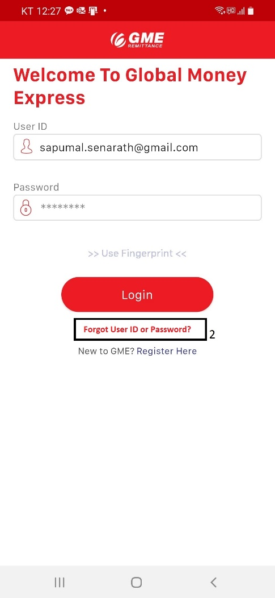

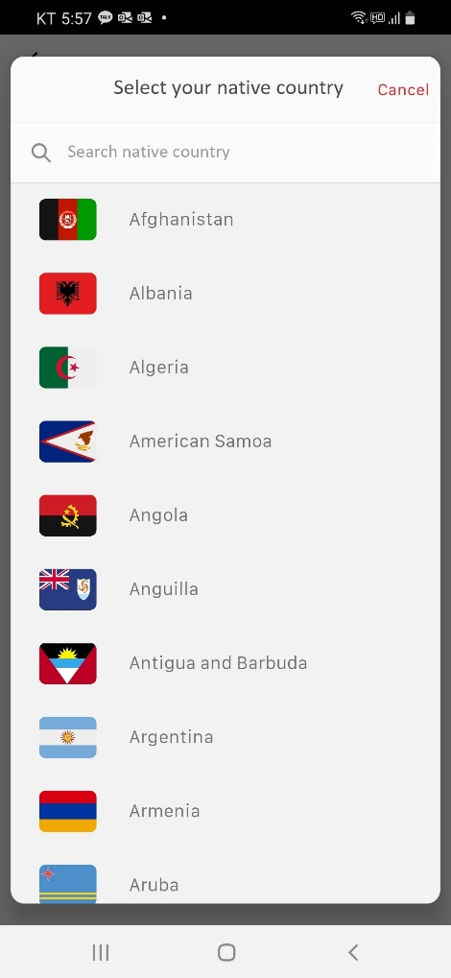

**Flow Charts**

Find ID